Usability Engineering – Assignment 4

Nachiket Rao

s3827657

RMIT University

**Introduction**

When striped to barebones essential requirements any collaborative application should provide the following basic functionalities –

* Easy to use for students and teachers who might not be well versed with computers
* Quick learning curve so as not to waste users time and let the focus be on teaching and creativity
* Handle simultaneous requests seamlessly without stutter

For this report, application in focus is Creately as well as 3 other applications to compare how group tasks are done in each application and using the results evaluate the usability.

# Application Description

1. **Creately:**

Functionality –

* Platform for designing flowcharts for various purposes (Database, Management, software design, UML etc)
* Documents available on cloud and across multiple devices
* UI created to be easy to use for enabling people to concentrate on their work as opposed to spending time learning the software

Group Collaboration –

* Owner of the document has ability to make the document publicly available, give access to individual people or create a shareable link which gives access to those with the link
* Owner can decide which user gets read or write access. Users with read access can only view the document while write access gives users the ability to edit simultaneously
* No audio or visual (webcam or screensharing) interaction functionality is provided and communication is limited to adding comments in the document

1. **Trello:**

Functionality –

* Dashboard provided wherein users can organize data into cards and lists to resemble a digital version of a whiteboard. Helpful in distribution of workflow for a major project
* Like Creately, data is available on cloud across multiple devices

Group Collaboration –

* Group functionality is similar to Creately wherein owner of the dashboard can invite people by adding them individually or sending a shareable link.
* Like Creately, there is no audio-visual communication features however interaction among people sharing the dashboard is more flexible wherein users can see the activities being performed by others and add comments and labels on individual cards.

1. **Collaborate Ultra:**

Functionality –

* Primarily a teaching platform to enable teachers to conduct online classes which students can join remotely across the world

Group Collaboration –

* Provides collaborators the ability to talk with each other in real time using their mics or send messages in a chat box
* Moderators are able share their screen as well as webcams if available
* Option to create breakout groups to divide the workload and allow breaking up of a large class into smaller groups.

1. **Microsoft Teams:**

Functionality –

* Serves as a collaborative communication platform allowing people to send calls, conduct video conferences, create teams and organize classes

Group Collaboration –

* Allows users to conduct video conferences, chat with other people, talk, share their application screen, and allows users to take remote control of the shared screen during a collaborative session.

# User Task Design

You have a group of 4 people as your final year project team. Your task to use the 4 applications to collaborate for designing and planning various aspects of the project.

# Results

|  |  |
| --- | --- |
| **Creately** | |
| Group Collaboration | 1. Team leader creates a common folder to store all project related files 2. People in the group then can create flowchart diagrams for database design, deployment, development lifecycle using the templates provided in the software 3. Each person can present his design to the group by giving them access to the document  4. Group members can leave comments if they have doubts or feel changes are required |
| User Task Results | 1. Excellent visual representation of the project  2. End-to-end design of the project achieved 3. Not suitable for design of user interface 4. Requires support of conferencing application for best output |
| Advantages | 1. Users able to quickly visualize through drawing flowcharts for their workflows. 2. Little to no learning curve for first time users. 3. Documents can be saved in different folders. 4. Owner has flexibility to choose between read and write access to documents |
| Disadvantages | 1. No audio-visual communication which makes interaction during collaborative tasks extremely difficult 2. Cannot be used as a standalone application for collaborative tasks as interaction is limited. 3. Application is severely limited when it comes to collaborative tasks. |

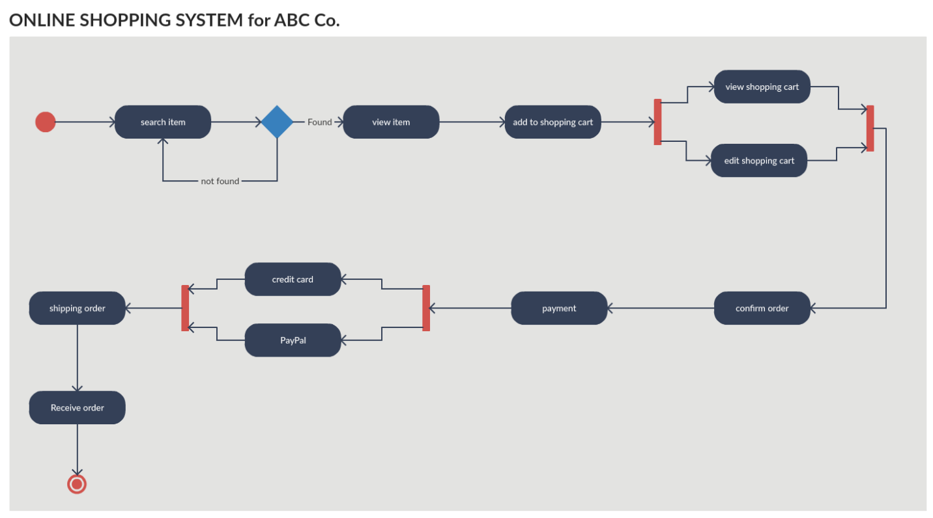

Overall Ranking – Great for visually representing ideas but lack of communication features make it a difficult application for standalone use

|  |  |
| --- | --- |
|  | **Trello** |
| Group Collaboration | 1. Team leader creates a board and sends a link to group. He can choose to add default lists 2. Group members can divide the workload by writing out tasks under lists and specifying who has to do what 3. Card sorting for the UI of the app is done by grouping elements of the application under different lists 4. Files and code snippets can be shared in card details 5. Members can view the progress and updates on the allocated tasks |
| User Task Results | 1. Allows for efficient task allocation 2. Easy to see updates 3. Requires some time learning the application |
| Advantages | 1. Excellent organization provided between cards and lists. In one glance users can understand division between workflows and tasks 2. Ability to see what each user has updated in real time. Useful for error correction in case the team feels some members are going the wrong way 3. Attachment file types is highly flexible. 4. Each individual cards can have lots of information encapsulated within |
| Disadvantages | 1. No audio visual element making interaction in real time difficult. Interaction Is limited to commenting on cards and viewing updates 2. Owner cannot restrict access rights to the board. By default all members have read and write access 3. Requires an initial learning curve to understand how to application works. Can be daunting for first time users |

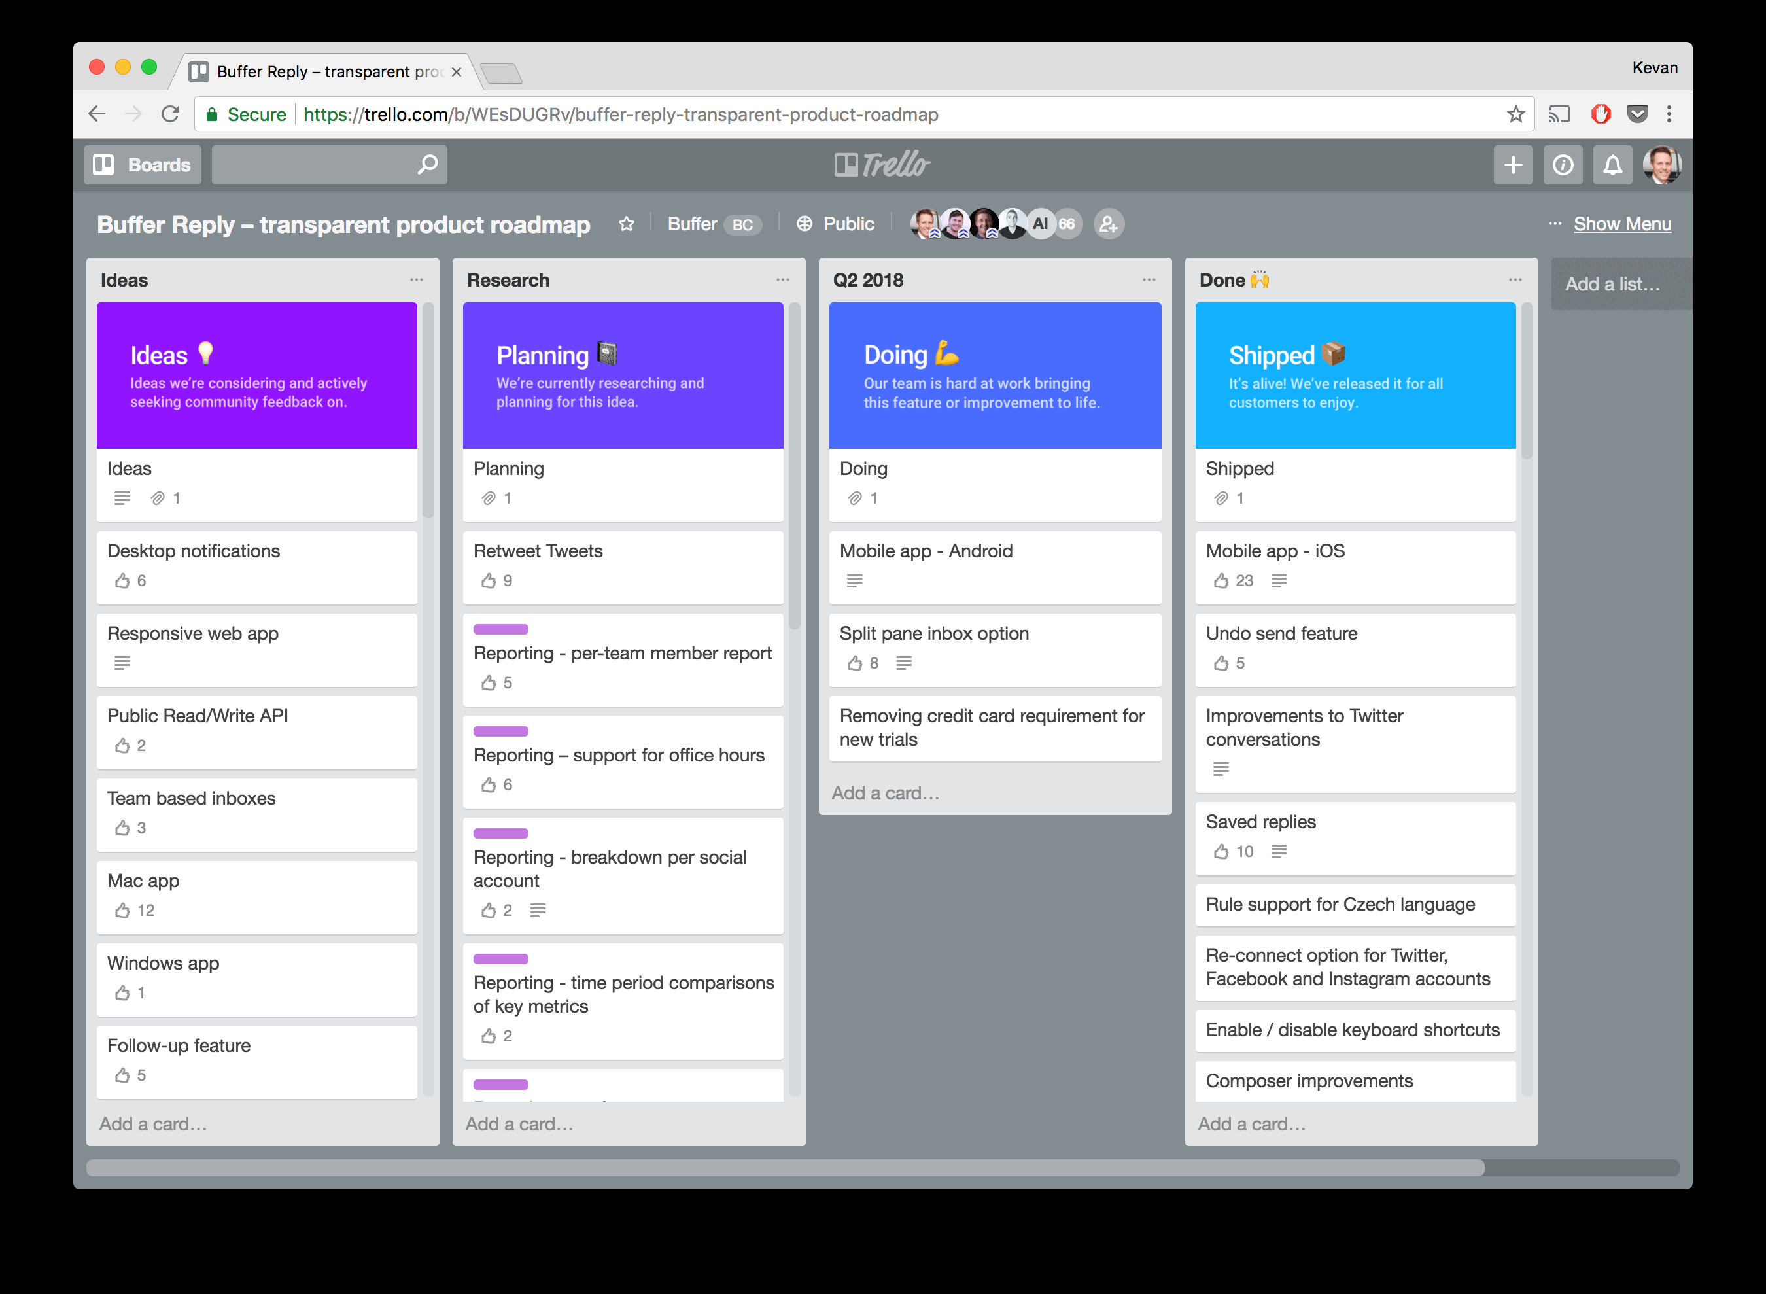

An example of using trello for a group project

Overall Ranking – Best application for creating virtual whiteboards, user interface planning and workflow division. Users note the lack of only read access feature. Application can be used by itself for certain tasks and more flexible than Creately in terms of communication

|  |  |
| --- | --- |
|  | **Teams** |
| Group Collaboration | 1. Team leader can create a new team in the application and add members 2. Regular meetings can be held where members can discuss about the project 3. Members can share their screen to solve doubts 4. Files and code snippets can be shared in the chats |
| User Task Results | 1. Members can communicate in real time 2. Allows to easily share ideas 3. Members can log in from their phone if urgent |
| Advantages | 1.Allows for audio visual interaction between groups including screen sharing, webcam sharing, calling, instant messaging 2. Groups can be organized into teams for sending updates to everybody in one go 3. Files shared across multiple sources avaialble at a single location under files tab 4. Chats in group sessions are saved for future access |
| Disadvantages | 1. Unlike creately and trello, Teams does not provide any dashboard or document for designing or sorting tasks. Users are left to their own to decide how to communicate their ideas efficiently 2. Call quality as well as system performance is noticiably affected when the number of users on a call increase |

Overall Ranking – Provides a great platform for video and audio conferencing. What it lacks in creative visual representation, Teams makes up for by providing communication features that allows users to share and discuss their ideas naturally

|  |  |
| --- | --- |
|  | **Collaborate Ultra** |
| Group Collaboration | 1. Requires an administrator to provide access to use the application 2. Members must be taken to a breakout room to discuss ideas 3. Members can discuss ideas and update each other on progress 3. Screen sharing done to facilitate doubt solving sessions |
| User Task Results | 1. Members can communicate in real time 2. Allows to easily share ideas |
| Advantages | 1. Allows for audio visual communication between groups of people to enable seamless interaction between teams. 2. Large groups of people can be divided into breakout sessions allowing for better distribution of workflow 3. Chat window provided for people to communicate  4. Session can be recorded and stored for future reference. This also records chat history |
| Disadvantages | 1. Application access is limited to teaching staff. There is no free tier available and students not allowed to create sessions. 2. Instances when people are unable to join using the session link 3. Cannot share files over a session 4. User cannot get control of the shared system screen if required |

Overall Ranking – Not the first choice for any task other than virtual classroom. Users don’t prefer the need for having an administrator to give access which they can directly get from other applications such as teams, google meets or zoom.

### References

[1] Quesenbury, W., 2004. Balancing the 5Es: Usability. Cutter IT Journal, 17(2), pp.4-11.

[2] Nielsen, J., 2000. Why You Only Need To Test With 5 Users. [online] Nielsen Norman

Group. Available at: <https://www.nngroup.com/articles/why-you-only-need-to-test-with-users/>

[Accessed 18 March 2020]

[3] Nielsen, J., 2012. *Usability 101: Introduction To Usability*. [online] Nielsen Norman Group.

Available at: <https://www.nngroup.com/articles/usability-101-introduction-to-usability/>

[Accessed 21 March 2020].